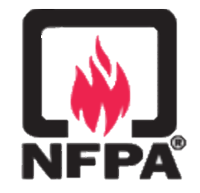
NFPA 20, 2019 Edition, &
NFPA 25, 2020 Edition

On-Line Training

Registration Form

NFPA 20 & 25 ONLINE TRAINING

May 2020 | Johannesburg, South Africa
NFPA 20: 17th – 19th May 2021 | NFPA 25: 21st – 23rd June 2021

Title:
Full Name:
Function:
Address:
City: |  |  |  |  |  |  | Zip Code:
Country: | South Africa  Other
Mobile Number:
E-mail Address:
VAT Number: |  |  |  | PO number (If Applicable):
NFPA Membership Number (if applicable):
Training Fee | ZAR 18,000 Excluding VAT |  |  |  | Training | NFPA 20 - 17, 18 & 19 May  NFPA 25 - 21, 22 & 23 June
Confirmation of Invoicing details |  | Invoice to be made out to details provided on registration form  Alternative invoicing details as provided below:

Cancellation Policy
Riskonet Africa reserves the right to reschedule or cancel the seminar at any time, without notice, for any reason, and without liability to registrants. Should the seminar be cancelled, for any reason the full tendered payments will be refunded to registrants.
We strive to let registrants know if a course has to be rescheduled or cancelled 20 working days before the event.
Cancellation requests made by registrants more than 20 business days prior to a seminar will be subject to an administration fee of 10% of the seminar price. Cancellation requests less than 20 business days prior to the seminar are not refundable but can be transferred to another person.
Cancellation requests must be submitted in writing via e-mail. If you have any questions or concerns about our cancellation policy, please contact us at info-za@riskonet.com or at +27 (0)73 013 0168.

